CMS Usability Review

Population Criteria

For reference, the following is a screenshot of the current design in Safari on OSX El Capitan:

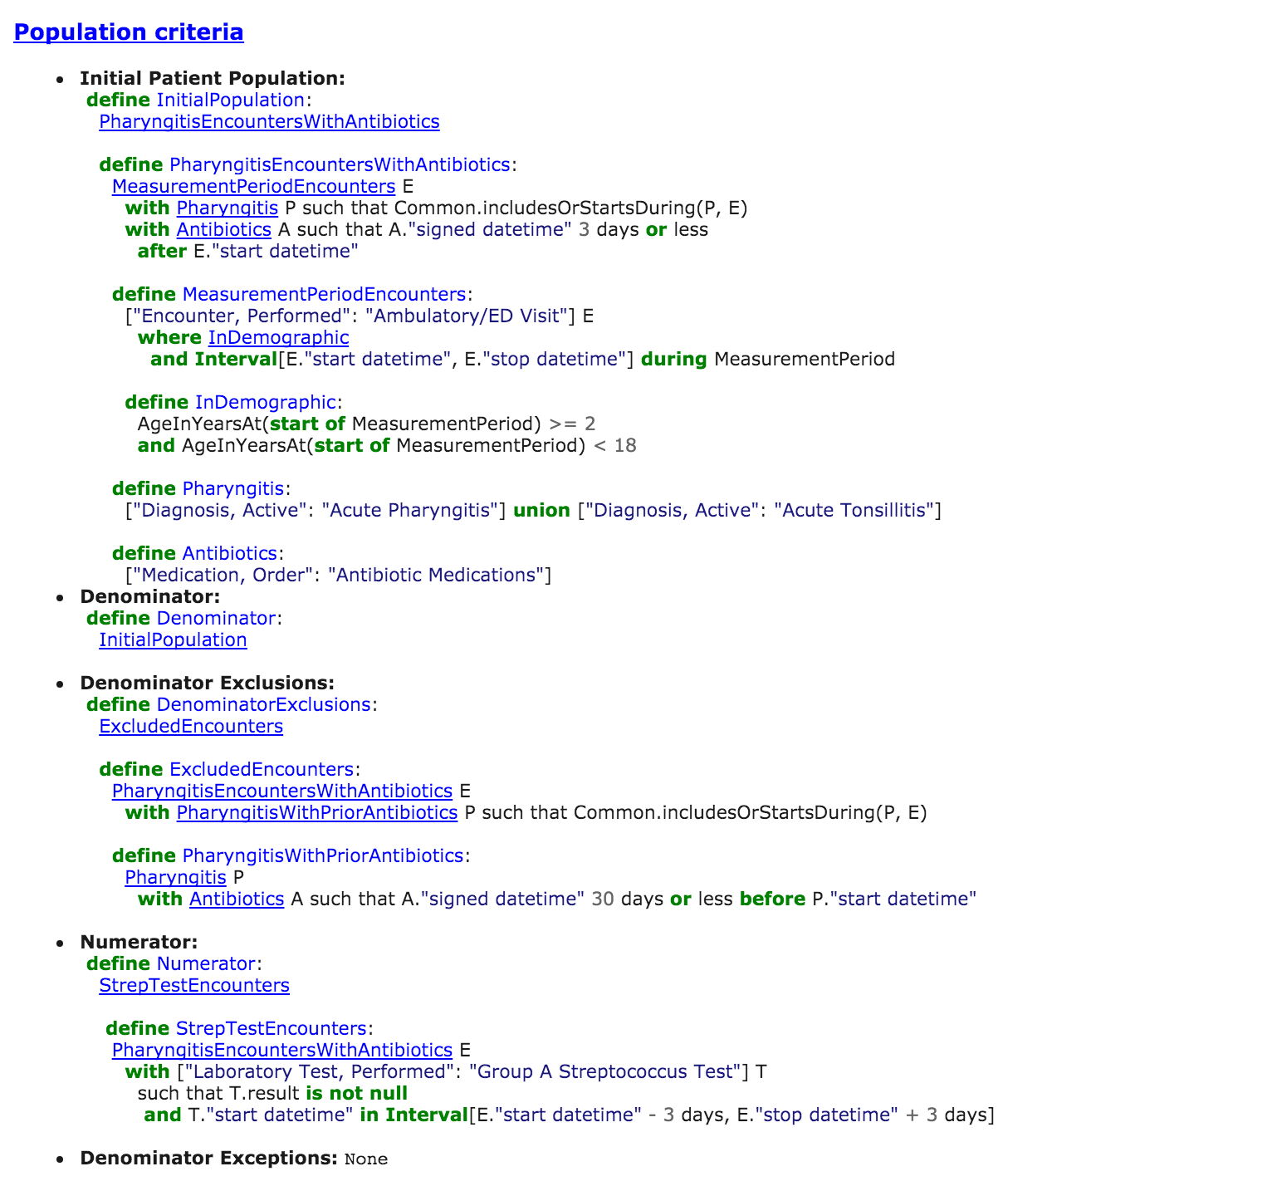

Observations and feedback:­­­­

|  |  |  |
| --- | --- | --- |
| **Observation** | **Proposed Solution** | ✓ |
| Anchor (link) tags on non-link content (such as "InitialPopulation" after "define" breaks usability conventions | Remove anchor tags for non-links | ✓ |
| Blue text for links and non-links confusing and underlining clickable links does not ameliorate the issue | Modify the color and font theme so that non-links don't look like classic links | ✓ |
| Code is wrapping even when it has available space. Additionally, single code lines should not wrap | Set overflow to use the horizontal scrollbar. Horizontal scrolling is not ideal, but it is preferable to wrapped, broken lines of code. | ✓ |
| Gray text is very difficult to distinguish from black text | Improve color theme readability | ✓ |
| Hierarchical levels difficult to follow and distinguish from one another | Show indentation level through colored tabs or dotted hierarchical lines (see https://www.hl7.org/fhir/questionnaire.html as an example) | ✓ |
| List items are too close together | Add margin/padding between them | ✓ |
| List item bullets add noise | Remove them, offset list items via spacing and formatting | ✓ |
| List item titles should be offset from their content | Remove colon, change font style, highlight content | ✓ |
| Find a way to more clearly highlight content of each list item | Change the background color, use distinguishing font family | ✓ |
| "Denominator Exceptions"'s None content should be stylistically consistent with the other sections | Show "None" as a commented section of code | ✓ |
| Titles have inconsistent capitalization ("Population criteria" -> "Population Criteria") | Capitalize titles consistently | ✓ |
| Code does not look like code due to font and color inconsistency | Change code font family and color scheme | ✓ |
| Clicking "Population criteria" and being sent to the Table of Contents is unintuitive | Make title unclickable, but introduce a separate link back to the table of contents | ✓ |
| define [class name]: [more specific class name] alias with indentation | Unless it's a part of the language, it's best to consider the beginning of the definition as a single statement on one line. This reduces unnecessary indentation and improves consistency | ✓ |
| Color scheme for types in code is incomplete | Match color scheme to other conventional schemes (e.g., objects should be a certain shade of blue, variables another, etc.) |  |
| The page isn't utilizing its horizontal width (set to use 80%) | Page width should either be 100% or there should be a maximum page width in pixels | ✓ |
| Local # links do not function as intended–if the remaining content is too scarce, the page fails to scroll to the desired element | Could pad out the page with whitespace to guarantee full scrolling to desired element | ✓ |
| Clicking a local # link results in a confusing teleportation and loss of context, as it happens instantaneously and does not provide feedback that the user is looking at something he/she selected | Unfortunately, any full solutions would require JavaScript–confusion could be slightly mitigated by making the thing being scrolled to more obvious (not just text, but a block of content) | ✓ |
| Ordering of Population Criteria items is inconsistent (Denominator items, then numerator, then another denominator item) | Order by grouping by category | ✓ |
| Code tabbing seems inconsistent (Sometimes the *define* statement’s second line matches that of the (presumably) nested *define* statement, and sometimes the nested statement is tabbed is doubly nested | Ask for clarification and match tabbing to improve consistency and readability | * |

508 (Accessibility) Review of CQL portion

Using a 508 compliance checking tool ( <http://achecker.ca/checker/index.php> ), I uncovered and fixed the following issues:

|  |  |
| --- | --- |
| **Issue** | **Repair** |
| (bold) element used | Replace your b (bold) elements with em or strong (strong usually renders as bold text, em as emphasized text) |
| Document language not defined | Add language tags to <html> (<html xmlns="http://www.w3.org/1999/xhtml" xml:lang="en" lang="en"> ) |
| Contrast between color of text and its background for the element not sufficient | Darken colors to create necessary contrast |

Additional Tasks

Introduce collapsible list items in Population Criteria—This is complete.

Hover over item to view a flyout definitions—The full implementation of this functionality is impossible without JavaScript. The most that can be done is changing the “title” text of each item to the desired definition. The user could view this definition by hovering over the item however long the browser determines is necessary. After all, it’s just a tooltip. Naturally, there are 508 (accessibility) concerns with using title text this way. This also precludes the functionality in an environment with no hover capability.